Laboratory work №8
Nonlinear Dimension Reduction

Task
Perform dimension reduction using Isomap, Locally Linear Embedding, Multi-dimensional Scaling (MDS), t-distributed Stochastic Neighbor Embedding (t-SNE) onto 2D and 3D space.
Analyze results. Find, which methods gives best results for Wholesale customers data.csv dataset

The script implements four dimensionality reduction methods – Isomap, Standard Locally Linear Embedding (LLE), Multidimensional Scaling (MDS), and t-SNE each configured to project the data into a 2D space. These methods are applied with specific parameters, such as n_neighbors=10 for Isomap and LLE to define local neighborhoods, and n_init=4 for MDS to control the number of initializations for stability. The 2D embeddings are visualized using matplotlib, with each method's results displayed in a subplot grid, allowing for a comparative view of how the data is structured in reduced dimensions.
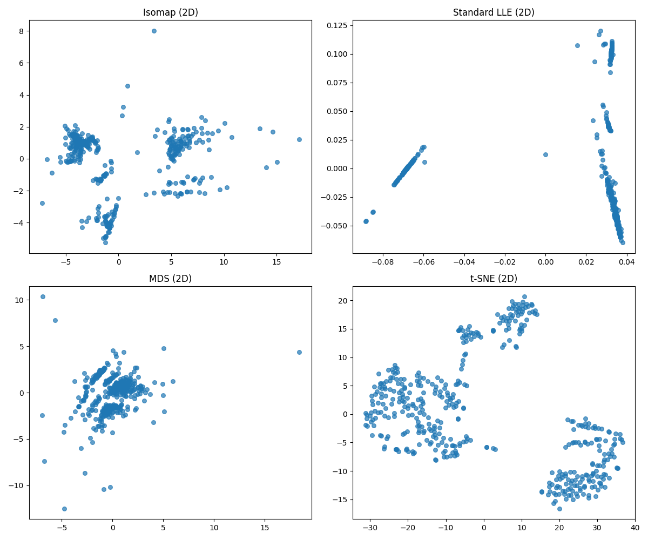
Figure 1 – 2D
Additionally, the script extends the analysis to a 3D visualization using Isomap, which is applied with n_components=3 to capture more variance in the data. The resulting 3D embedding is plotted using a 3D scatter plot, with components labeled on the axes, providing a deeper perspective on the data's manifold structure. This visualization highlights the spatial distribution of data points, which can reveal clusters or patterns not as evident in 2D.

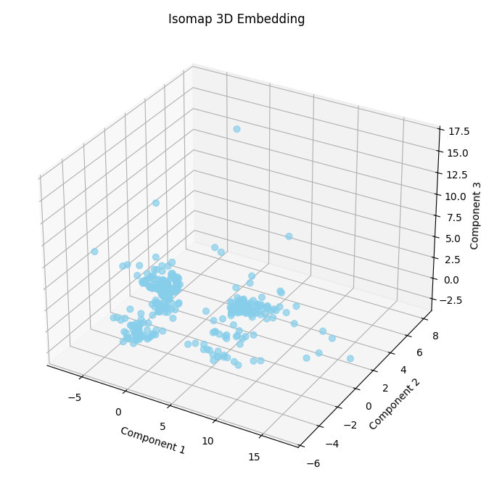
Figure 2 – 3D visualization

The Python script effectively applies dimensionality reduction techniques (Isomap, LLE, MDS, t-SNE) to the "Wholesale_customers_data.csv" dataset, transforming its numerical features into 2D and 3D visualizations. Standardized data reveals distinct patterns: Isomap and MDS preserve global structure, while LLE and t-SNE highlight local clusters. The 3D Isomap plot suggests potential customer segments, demonstrating the value of these methods for exploring complex spending data.

